Student Grades Application

CP 212 - Assignment 5

By: Christian Reichenbach

190608390

**Executive Summary**

When grades are finally in there can be a mass amount of information that hits professors and instructors, some being about grades for each assignment, midterm, exam and multiple for each student. After marking for countless hours it becomes quite overwhelming to review these final grades and assess how your class fared in the current term.

This student grades application allows for professors and instructors to review the grades of different classes in the current semester, this program has an array of functions to review current information ranging from calculating the average and standard deviation of a specific classes grades, displaying the current class list for the semester, viewing the enrollment for a specific selected class and lastly to generate a report of the grade distribution in each class for that semester.

In this report an explanation will be given on how to use each function of this program along with some quick information on what was learned in the process of making this project and what assistance was used when creating the student grades application.

**Application Instructions**

Since the application is split into four main functions this section of the report will explain how to use each function. But before you get to any of the four functions you must choose the database that you would like to take your student grades from. This is done in the first userForm shown when clicking the ‘Begin Here’ button. To choose your database to use you need to first hit the select data button and then navigate to the database file on your file explorer to then choose the path. Once the path is chosen and displayed in the text box you can click the Run button and you are now on your way to running some of the functions.

**List Courses**

In this function it is very simple to run its full function, first you must click the show list button which will pull from the database all the course names and then display them in the list box. From here you can view all the classes in the system and whenever you are ready to leave you can click the cancel button to exit the application.

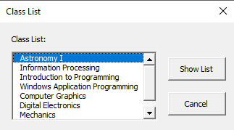

**Enrollment List**

This function poses similar to the previous course list function however it takes it one step further. This extra step would be the fact that it now will pull a class list of all the students in a specific class based on what the user has selected. Just like the course list function a list box will display all the classes in the database, from here the user may select a class by clicking on it in the list box, it is said to be selected when its area is highlighted in blue. Once a class is selected then click the View Enrollment button which will then go through the process of creating a new worksheet displaying the first and last names of all the students found to be in that class.

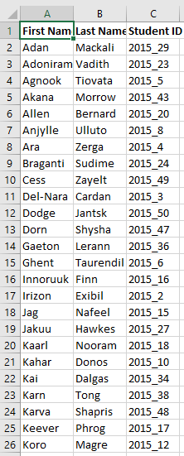

**Calculate Average**

The calculate average function allows for the user to select a class from a course code list and see the class average along with the standard deviation of that class's grades. To use this function you first need to click the show list button to see all the courses you can select to see the averages and standard deviation. Just like the enrollment list function you will need to select a class and from there and you can now click the calculate average button which will proceed to pull information on grades from the database for that specific class, calculate the average and standard deviation and then display both in a message box for the user to see.

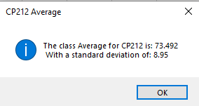

**Generate Report**

The report function does not require any real inputs from the user to complete the function. This is because it does not need to specify which class to pull data from or anything of a similar matter, instead it takes data from all classes and generates the report and worksheets individually for each class. To do this the function first works to create the initial report Word document, this will write the title into the doc and a brief explanation of the report. Now the function can work with the data first specifying which class is being used and next grabbing all the grades from that class. Once all the grades are calculated it can be inputted to a new worksheet and create a frequency table. The frequency table is then used to create a grade distribution histogram and that chart is added to the Word doc with a quick explanation along with the average and standard deviation of that class’s marks. Once each class has been run through the report is saved and the function is now finished.

**Learning and Conceptual Difficulties**

When completing this project there were many things that I learnt but the biggest learning point would be learning how to plan out a program of such size. Up until now all of my projects have been smaller in size and not taken many lines of code to complete, however this project was not the same. At first as I thought through what I wanted my project to be like it was very overwhelming to think of it all at once as I wanted to know exactly how I was going to code it right off the bat. After thinking a little further I realized it would not be very beneficial to think of my project in this manner and instead I should think of it as more of a bigger picture at first and then work in parts once that larger picture was produced. This proved to be very helpful as I first established the functions I wanted to have and then thought of the main process which led me to creating these different sections I could work on individually.

Another challenge was making sure my code was modular and reusable, at first I did not plan my functions very well and this led me to repeat large portions of code in different functions just to get similar results. After realizing this I looked over my code and made it much more modular and reusable which I kept doing for the rest of the project.

**Assistance**

Throughout the course of this project I used many different facets to learn how to complete some aspects of my code. One main facet would be the lecture slides from this course which I used to help understand both how to make charts in VBA and generate Word Documents. In addition I also used the internet to search up different documentation for VBA methods and expressions in order to learn how to properly use the code.